**GENERAL INTEGRATED SCIENCE – UNIT 4**

**TASK 9 – ENERGY CHANGE PRATICAL**

**NAME: _________________________________ WEIGHTING 9%**

**MARK: ______________________ / =________ % /49**

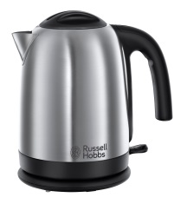

**Aim:** To determine the energy inputs and outputs used in edible food production.

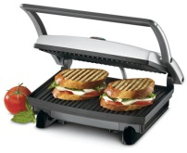**Materials:**

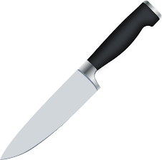Kettle   
Sandwich Press  
  
Sharp kitchen knife *use with caution*  
Cheese   
Ham  
Tomato

**PART A**

A loaf of bread is made up of flour and other ingredients. The flour comes from wheat which is grown on farms. Look at the diagram below and state the energy changes that occur when wheat grows until bread is eaten by an athlete.

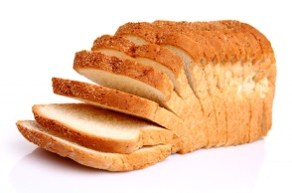  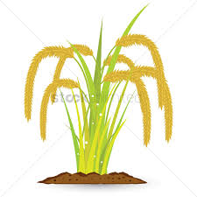 

sun wheat bread athlete

State the energy types in each object

1. Sun: _____________­­­­­­­__________and ________________________ (2 Marks)
2. Wheat ___________________________________________________ (1 Mark)
3. Bread ___________________________________________________ (1 Mark)
4. Athlete __________________, ______________ and ____________ (3 Marks)

**PART B**

1. Using the knife cut the tomato and cheese into slices.
2. Record the energy input type and output type(s) required to cut using a knife.

(2 Marks)

|  |  |  |
| --- | --- | --- |
| **Energy input** | Image result for kitchen knife | **Energy(s) output** |

1. Using the kettle boil hot water to make your-self a drink.
2. Record the energy input type and output type(s) required to boil water using a kettle. (2 Marks)

|  |  |  |
| --- | --- | --- |
| **Energy input** | Image result for kettle | **Energy(s) output** |

1. Using the sandwich press, make yourself a toasted sandwich.
2. Record the energy input type and output type(s) required to make a toasted sandwich in a sandwich press.   
    (2 Marks)

|  |  |  |
| --- | --- | --- |
| **Energy input** | Image result for sandwich press | **Energy(s) output** |

1. Of the three devices, which is the least energy efficient? What evidence is there to support this? (2 Marks)

**PART C**

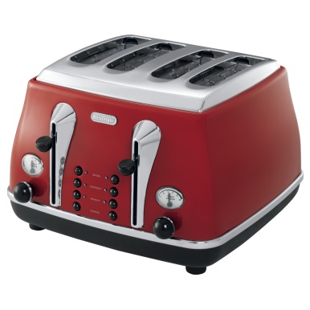Your family has asked you to help them choose the best toaster to buy. There are two brands to choose from.

**Brand A Toaster**

Price = $260

Power rating = 80W

Efficiency = 23.5%

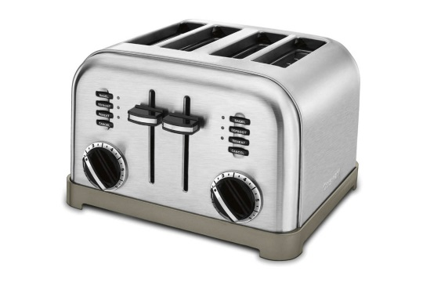

**Brand B toaster**

Price = $285

Power rating = 125W

Efficiency = 32%

1. What do these toasters have in common? (1 Mark)
2. If you put a slice of bread in each toaster, which toaster would turn the slice brown first? Explain your answer. (2 Marks)
3. If each toaster has a lifespan of 10 years, which one would be the best buy? Explain your answer. (3 Marks)

**PART D**

In a circuit below, a power supply is connected to an electric bulb. The ammeter measures the amount current flowing through the bulb. The voltmeter measures the voltage across the bulb as shown below. The bulb used is usually found lighting the living rooms in many homes.

Ammeter

Power supply Voltmeter

12V bulb

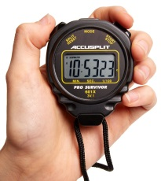

Stop watch

You are required to determine the amount of electrical energy flowing into the bulb in two minutes.

Record your results below (3 Marks)

1. Voltage, V = ______________________ Volts

Current , I = ______________________ Amps

Time, t = _______________________ seconds

1. Calculate the INPUT electrical energy. Hint: E = V x I x t (2 Marks)
2. The bulb used is not **energy efficient**. What does this mean? ( 1 Mark)
3. The bulb produced 1000 J of heat. How much **light energy** was produced?

(2 Marks)

**PART E**

The following electrical gadgets are found in most households.

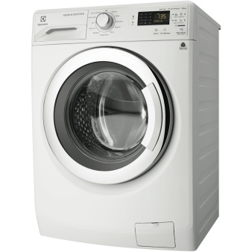

**Washing Machine**

Input electrical energy = 600J

Output movement energy = 375J

Output sound energy = 225J

**Microwave Oven**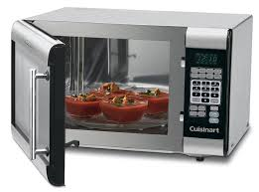

Input electrical energy = 1200J

Output light energy =300J

Output heat energy = 900J

(a) Calculate the efficiency of each gadget. (4 Marks)

**Washing Machine:**

**Microwave oven:**

(b) Which device is least efficient? (1 Mark)

(c) Both gadgets use electricity. Electricity flows through metal wire to reach electrical devices. Why is plastic used to coat these wires? (1 Mark)

**PART F**

Morgan is a keen basketball player. He carried out an investigation to find out how good the basketball was at bouncing. He dropped a 600g ball from a height, H1 = 15m from the ground. The ball rebounded up to a height, H2 = 6m.

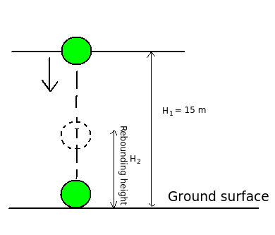

1. How much gravitational potential energy did the ball have before he dropped it?

(3 Marks)

1. How much gravitational potential energy did the ball have on rebounding? (2 Marks)
2. How much energy was lost as heat and sound? Explain your answer. (2 Marks)

**PART F: Heat lost by water**

You are going to find out how much heat is lost when water cools down. Heat some water in a kettle. Measure the starting and final temperatures.

1. Measure and record the volume of water.

Volume = ________________ml (1 Mark)

1. What is the mass of water? Hint: **1ml has a mass of 1g**

Mass = _____________________ g (1 Mark)

Mass = _____________________kg (1 Mark)

1. Starting temperature, T1 = _______________________ degrees Celcius
2. Final temperature, T2 = ________________________ degrees Celcius
3. Temperature difference, T1 – T2 = ___________________ degree Celcius (2 Marks)
4. Calculate the heat lost , E = mass ( kg) x4180 x temperature change. (2 Marks)